Week One
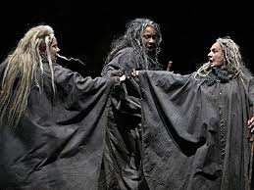 Macbeth Act 1 Reflection
- What evidence do we have in Act I, Scene II, of Macbeth’s bravery?
- In Act I, Scene III, who seems more affected by the witches’ prophecies, Macbeth or Banquo? Explain.
- Who seems the stronger in Act I, Scene V, Lady Macbeth or Macbeth? Explain.

Week Two
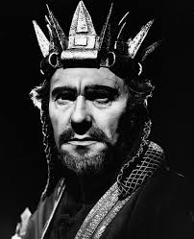 Macbeth Act 2 Reflection
- Is there any indication in the final scene of this act that Macduff is not pleased to see Macbeth crowned? Explain.

Week Two
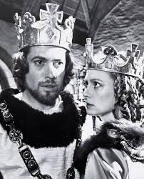 Macbeth Act 3 Reflection
- In Act III, what evidence is there that Macbeth now acts independently of Lady Macbeth and that he no longer confides in her? Provide evidence from the text.
- Macbeth is a man of imagination. Explain how his imagination has become his enemy in Scene IV.

Week Three
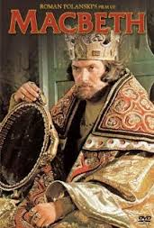 Macbeth Act 4 Reflection
- Shakespeare revels in several of his plays his strong belief that if a rightful ruler is deposed or killed, only chaos can result. State briefly how events in Macbeth emphasize that point.

Week Three
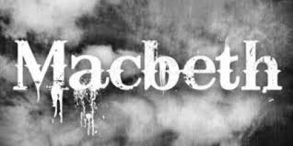Macbeth Act 5 Reflection
- How had power made Macbeth evil?

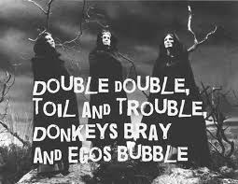Week Four
- Which do you see as the most important theme in the play? Explain.

